IT24101452

Lab 05

Q1.

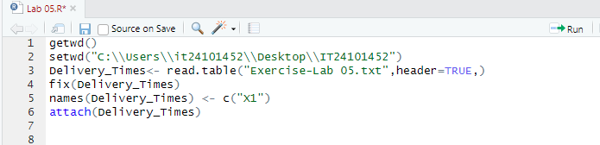

Q2.

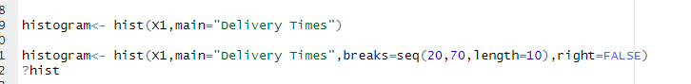

Q3.

The distribution of delivery times is approximately symmetric, with a slight spread around the center.

Q4.

